CS-331 Software Engineering and Project Management

HealthMate - Hospital Management System
Ghulam Ishaq Khan Institute of Engineering Sciences and Technology
Software Requirements Specification
[Version 1.0, October 15,2025]

Team Members Supervisor Details
Salman Shahzad Ali – 2023504 DS Dr Farah Saeed
Muqeem Ahmad Soomro – 2023561 DS Assistant Professor FCSE
Syed Murtaza Salman – 2023694 DS farah.saeed@giki.edu.pk
Ashir Siddiqui – 2023385 DS
Table OF Contents
- Page 1 – Title Page and Institute Name.
- Page 2 – Team Information and SRS Introduction.
- Page 3 – SRS Overall Description, Specifications Requirements and External Interface Requirements
- Page 4 – System Models Use case diagram and Class Diagram
- Page 5 – System Models Sequence diagrams 5.3.1-5.3.3
- Page 6 - System Models Sequence diagrams 5.3.4

Team Information
Salman Shahzad Ali 2023504
Syed Murtaza Salman 2023694
Muhammad Ashir Siddiqui 2023385
Muqeem Ahmad Soomro 2023561
- Salman Shahzad Ali – Will work on the development of Artificial Intelligence and will try to train a restricted domain model for use of chatbot.
- Syed Murtaza Salman – Will work on the training of the model and making the chatbot better and better also will make the User interface of the project.
- Muhammad Ashir Siddiqui – Will learn new Artificial Intelligence techniques and help his fellows in making of backend by working on Postgresql.
- Muqeem Ahmad Soomro – Will make a solo chatbot and integrate with the other group members and also will make a design for the User interface will also help in making the user experience better.
Software Requirements Specification
Introduction
- Purpose: The purpose of developing this project is to provide a means of efficient conversation between users and doctors which are an Artificial Intelligence chatbot in this case.
- Scope: The system will have domain restricted chatbots developed on datasets and provide a chatting platform to users meaning patients. The system will not provide any sort of Physical interaction between doctors and users.
- Definition: React which is a framework to develop frontend. Artificial Intelligence which will be used to make chatbots.
- Overview: This product is the SRS for HealthMate application developed under the supervision of Dr Farah Saeed. It provides all the necessary information which should be present in a SRS document such as systems objective, UML, system models.
Overall Description
- Product Perspective: This system basically enhances the current functionalities of online consultation between users and doctors. There are applications present in todays world that do provide communication but so far none has incorporated Ai chatbots.
- Product Features: Initial chatbot to listen to patient queries and guide them to the right doctor. Sessions with Specialized Doctors to handle advanced level queries. Providing a resolution to patients after the checkup is done. Use of Ai to make all functionalities better.
- User characteristics: Mainly the staff/students/faculty of Gik institute will use this for their daily medical issues and even can use it in case of some major problem. Everyone using this application must have basic knowledge of how to use a cell phone and type message. No high-level skills are required for this.
- Constraints: Limited knowledge of Artificial intelligence the students have while making this application and the students are highly dependent on tools of large language models. Plus, it might be a challenging task to develop such a huge project in just 3 months.
- Dependencies: We might have hundred percent dependency on the Application programming interface keys of large language models as to make our chatbot work in case we are not able to train a model of our own.
Specifications Requirements
Functional Requirements
- The system shall allow the users to login/register.
- The system shall admins to view Doctor information update/delete.
- The system shall make a means of chatting between patients and different chatbots to accommodate patients.
Non-Functional Requirements
- The system shall respond to user queries within two seconds.
- The system shall be available to all users 24/7.
- The system shall provide a very user-friendly experience to all users.

External Interface Requirements
- User Interfaces: The screen will have options for selecting between chatbots which will be labeled properly so that users will not have to be confused.
- Hardware interfaces: A cellphone/laptop is enough
- Software Interfaces: Postgresql will be used to store user data. External Apis may not connected in case a domain restricted model is not trained.
- Communication interfaces: The systems will communicate on basis of Wifi.
System Models
5.1 Use Case Diagram
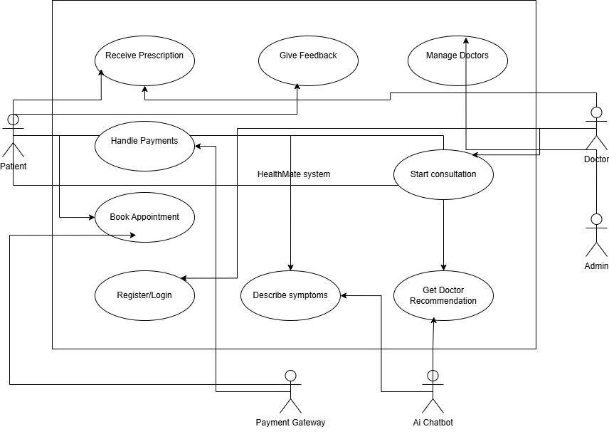
Figure 5.1 - Use Case diagram showing actors and major use cases (Patient, Chatbot, Doctor, Admin).
5.2 Class Diagram
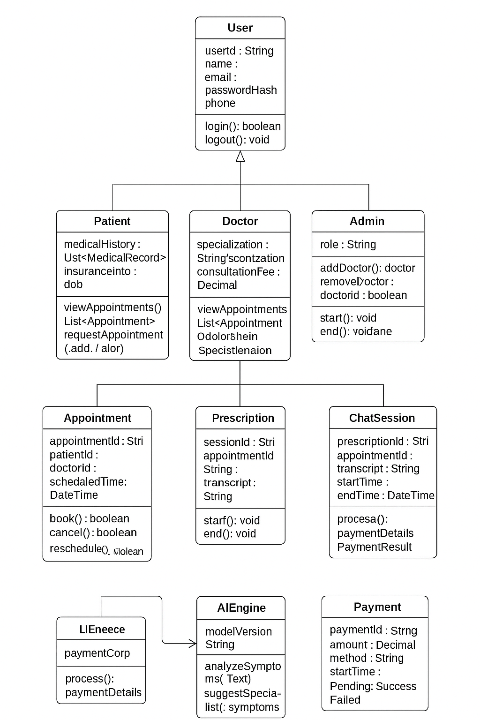
Figure 5.2 — Class diagram for main domain classes (User, Patient, Doctor, Appointment, ChatSession, AIEngine).

5.3 Sequence Diagrams
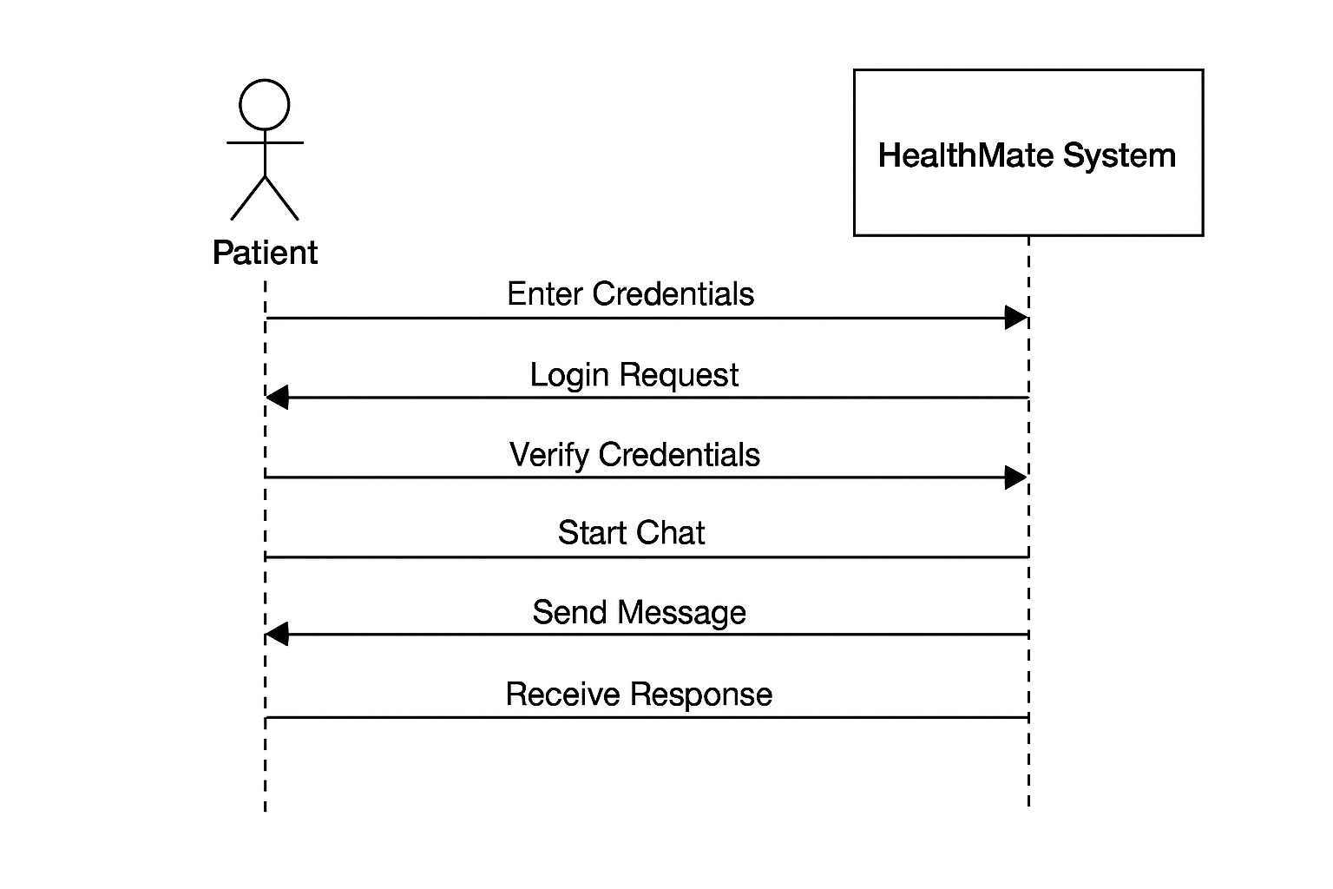
Figure 5.3.1 — Sequence diagram (Salman): Patient Login + Chat Initiation.

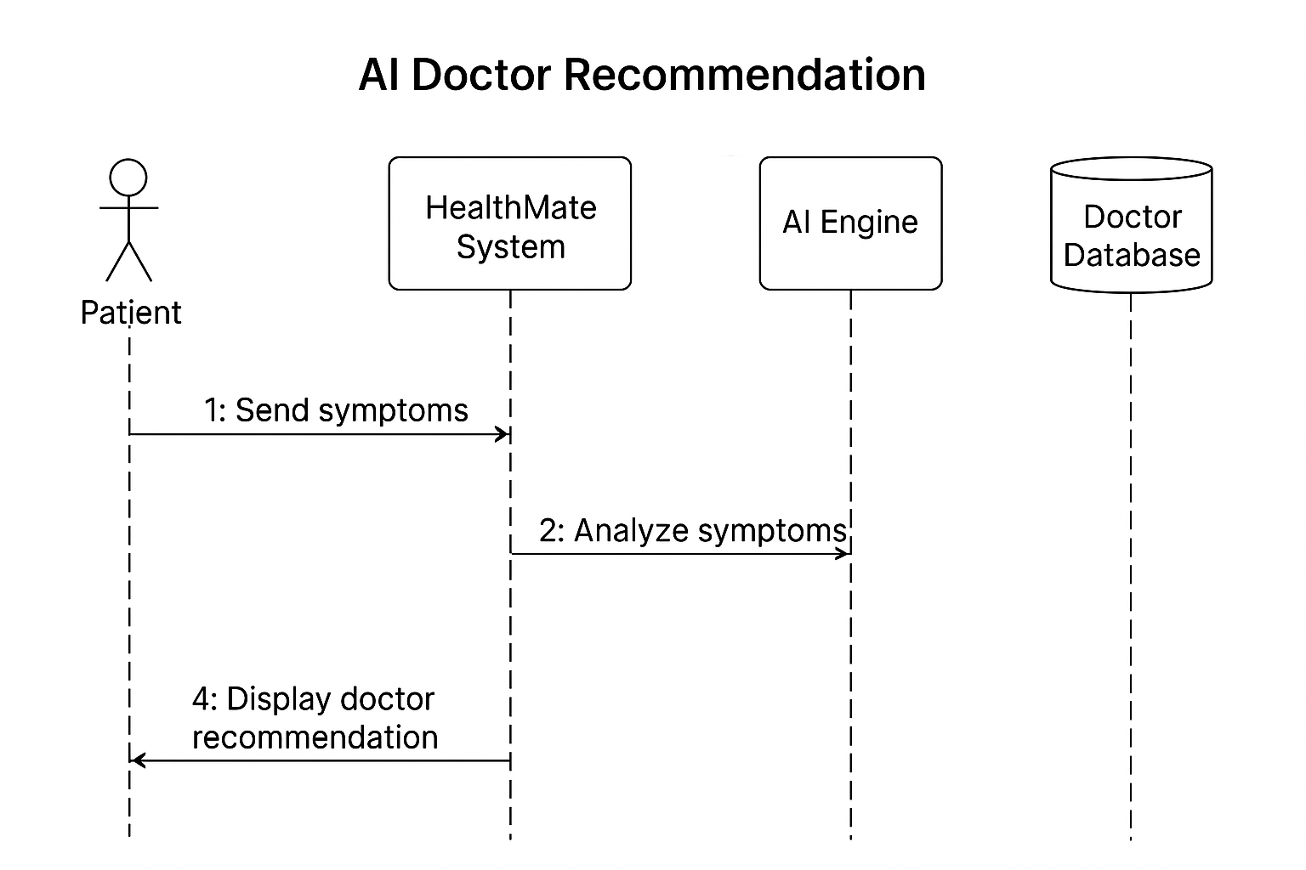
Figure 5.3.2 — Sequence diagram (Muqeem): AI Symptom Analysis & Doctor Allocation.
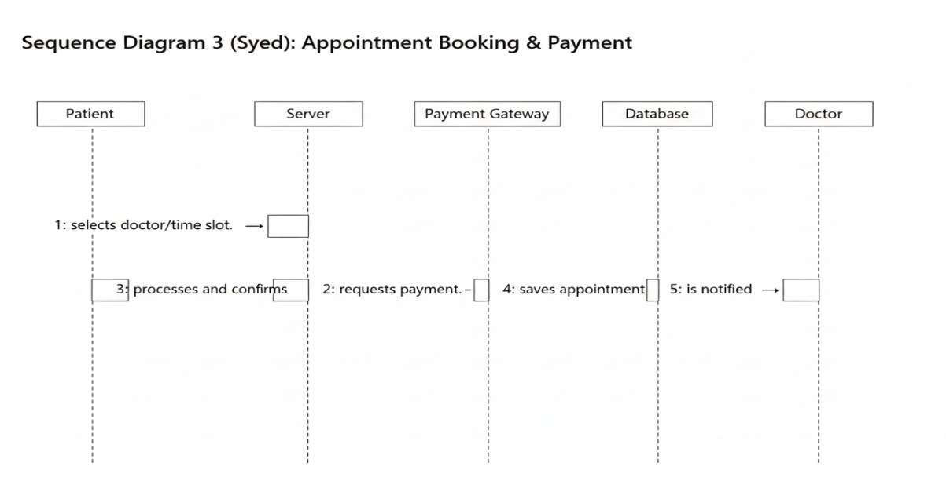
Figure 5.3.3 — Sequence diagram (Syed): Booking & Consultation Start.
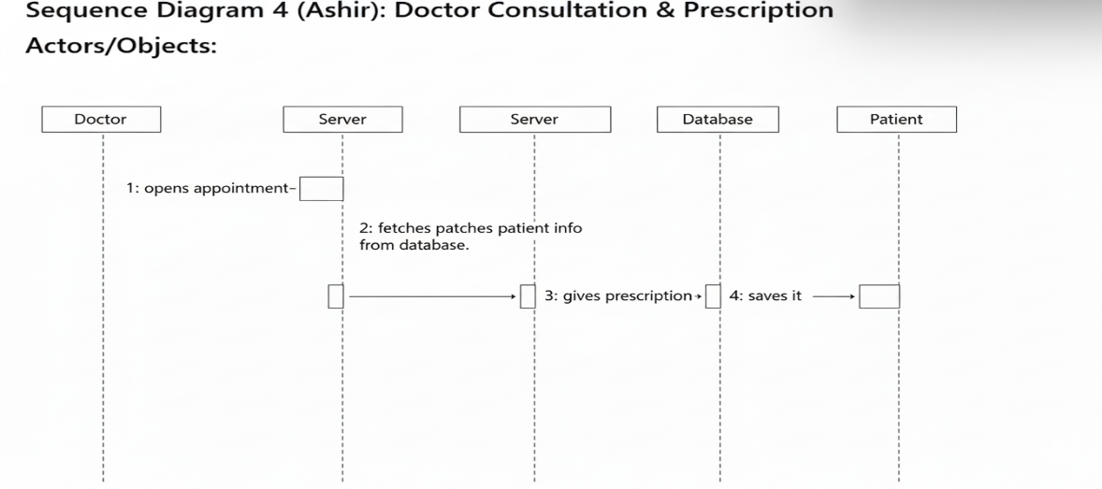
Figure 5.3.4 — Sequence diagram (Ashir): Prescription Issuance & Notification.

